SUMMER INTERNSHIP REPORT GUIDELINES

CONTENT

- Cover page (as per given format)
- College certificate (as per given format)
- Company / organization certificate
- Acknowledgement
- Abstract
An abstract gives the essence of the report (usually less than one page). It must contain the purpose and scope of internship, the actual work done, conclusion arrived at.
- Table of Content (as per format given below)
- List of Figures (as per format given below)
- List of Tables (as per format given below)
- Description of company / organization
Summarize the work type, administrative structure, number of employees etc. provide information regarding: Location and spread of company, division of the company, your group and division, Administrative tree, main functions of the company, customer profile and market share.
- Chapters 1 to N ( depending on you work you can discuss with your internal guide)
- Conclusion
- References

FORMAT

Paper size | : | A4
Margin | : | Left | : | 1.25 Inches |  |  | Right |  | : | 1.0 Inches
 |  | Top | : | 1.0 Inches |  |  | Bottom |  | : | 1.0 Inches
Header | : | Top-left |  |  | : | Student ID
 |  | Top-right |  |  | : | Chapter heading
Footer | : | Bottom-Left |  |  | : | CSPIT
 |  | Bottom-center |  |  | : | Page number
 |  | Bottom-right |  |  | : | Smt. Kundanben Dinsha Patel Department of Information Technology
Page number | : | All pages in the report except the cover pages and certificates must be numbered.  The page numbering starting from Acknowledgement up to the beginning of the chapters should be numbered in small roman letters, i.e. i, ii, …  The page numbering starting from the beginning of Chapter 1 up to the end of the report, should be numbered in Arabic numerals, i.e. 1,2, 3,….
Font | : | Type |  |  | : | Times New Roman
 |  | Size & Style |  |  | : | Chapter Heading |  | : | 16pts - Bold - All capital
 |  |  |  |  |  | Section Heading |  | : | 14pts - Bold - All capital
 |  |  |  |  |  | Subsection Heading |  | : | 12pts - Bold - Only first letter capital
 |  |  |  |  |  | Normal Text |  | : | 12pts – Normal
 |  | Color |  |  | : | All the text including Tables should be Black prints  However, Graphs and Figures can have color prints
Spacing  &  Alignment | : | 1.5 spacing between lines of regular text  Double spacing between:  Paragraphs  Chapter title and section heading  Section heading and paragraph v  Table title and table  Figure title and figure  Single spacing between:  text corresponding to bullets, listing and quotes in the main body of text  All paragraphs in the report are to be fully justified from the first line to the last line and should start from left without any hyphenation/indent. Text corresponding to bullets, listings and quotes in the main body of text should be indented.
Section &  Subsection numbering | : | Section numbering should be left justified using bold print with Arabic numerals and decimals.  Section numbering: <Chapter.Section number> <3 blanks> Section heading  Example:  In chapter 1 you have first section of introduction then it must be written as below  1.1 INTRODUCTION  Subsection numbering: <Chapter.SectionNumber.SubsectionNumber> <3 blacks> Subsection heading  Example: 1.1.1 Why new technology?
Equation & Formula | : | Numbering for equation if necessary, should be done in the following format:  (Chapter number. Section number. Equation serial number)  Example:  If given equation is in chapter 3 in section 3.1 and its first equation then number must be 3.1.1 and need to written as below.  Y= mx + b (3.1.1)
Figure | : | Figure number need to write below figure in following format:  Fig. <blank> Chapter number. Figure Serial number <3 blanks> Figure title (center aligned, leading caps)  Example:  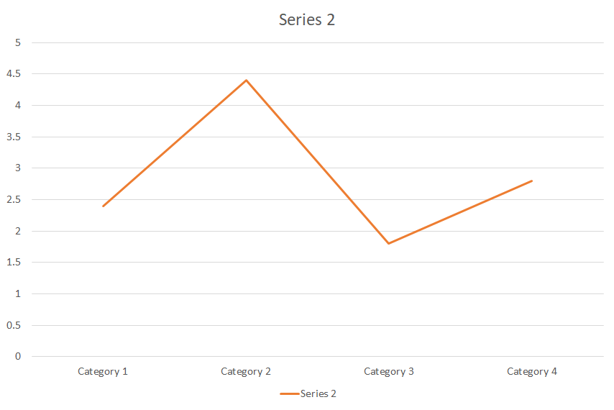  Fig. 6.10 Typical Component Event
Tables | : | Table number need to write below tale in following format:  Table <blank> Chapter number. Table Serial number <3 blanks> Table title (center aligned, leading caps)  Example:  Table 3.1 Semester Course table
  Semester | Course
  3 | Data Structure
  6 | Theory of Computation
  7 | Machine learning
References | : | All books, web references, research papers etc. you have referred for this work need to be listed in references. Write them in below given format:  Research Paper:  - Author name, “Paper title”, conference name / journal name, page number, year of publication  Books:  - Author name, Book title, Publisher, year of publication  Web reference:  - Absolute URL of site or web page  Bullet must be numbered and in []. They must be continuous. First write paper then books and then web references. In case of web references don’t write www.google.com etc. write full URL of web page / site that you have referred.
Binding | : | Spiral binding
Copies | : | No. of students + 1 college copy

Table of Contents
Abstract iii
Acknowledgement iv
Description of company / organization……………………………………………….ix
Chapter 1 How to apply 1
1.1 Introduction to Topic 2
1.1.1 How to do 3
1.1.1 How to do 3
1.1.1 How to do 4
1.2 Introduction to Topic 4
1.3 Introduction to Topic 5
1.4 Introduction to Topic 6
Chapter 2 Motivation of Research 8
2.1 Introduction to Topic 9
2.1.1 How to do 10
Chapter 3 Game Theory 11
3.1 Introduction to Topic 14
3.1.1 How to do 16
3.2 Introduction to Topic 17
References 40
List of Figures

Fig 1.1 My first C program 2
Fig 1.2 My second C program 5
Fig 2.1 My first C program 12
Fig 2.2 My second C program 15
Fig 2.3 My first C program 22
Fig 2.4 My second C program 25
Fig 3.1 My first C program 32
Fig 4.1 My second C program 35
Fig 4.2 My first C program 42
Fig 4.3 My second C program 43

List of Tables

Table 1.1 My first C program 2
Table 1.2 My second C program 5
Table 2.1 My first C program 12
Table 2.2 My second C program 15
Table 2.3 My first C program 22
Table 2.4 My second C program 25
Table 3.1 My first C program 32
Table 4.1 My second C program 35
Table 4.2 My first C program 42
Table 4.3 My second C program 43

